**Submission Form**

**Fill up the following slots with appropriate content. You must submit the content of this document from this page only.**

1. Your Name : Shadab Iqbal
2. Your ID: 19101072
3. Your Section : 09
4. Experiment No: 01
5. Experiment Title: Verifying the inverse square nature of Coulomb's law and determining the value of Coulomb's constant, “k”.
6. **You must write your ID in each of the graphs you insert here.**
7. **Table 1**: both charges are **positive**

Q1 = 3 uC

Q2 = 7 uC

|  |  |  |  |  |  |
| --- | --- | --- | --- | --- | --- |
| **Sl:** | Distance ***r (meter)*** | https://www.google.com/chart?cht=tx&chf=bg,s,FFFFFF00&chco=000000&chl=log%28r%29 | https://www.google.com/chart?cht=tx&chf=bg,s,FFFFFF00&chco=000000&chl=%5Cfrac%7B1%7D%7B%7Br%7D%5E%7B2%7D%7D | Electrostatic force ***FE*** | https://www.google.com/chart?cht=tx&chf=bg,s,FFFFFF00&chco=000000&chl=log%28%7BF%7D_%7BE%7D%29 |
| 1. | 0.014 | -1.853871964 | 5102.040816 | 962.952 | 2.98360464 |
| 2. | 0.02 | -1.698970004 | 2500 | 471.846 | 2.673800278 |
| 3. | 0.026 | -1.585026652 | 1479.289941 | 279.199 | 2.445913858 |
| 4 | 0.032 | -1.494850022 | 976.5625 | 184.315 | 2.265560681 |
| 5 | 0.045 | -1.346787486 | 493.8271605 | 93.204 | 1.969434551 |
| 6. | 0.058 | -1.236572006 | 297.2651605 | 56.105 | 1.749001567 |
| 7. | 0.063 | -1.200659451 | 251.9526329 | 47.553 | 1.677177921 |
| 8. | 0.08 | -1.096910013 | 156.25 | 29.49 | 1.469674773 |
| 9. | 0.091 | -1.040958608 | 120.7583625 | 22.792 | 1.357782436 |
| 10. | 0.1 | -1 | 100 | 18.874 | 1.275863951 |

1. **Table 2:** one of the charges are positive and another is negative.

Q3 = 7 uC

Q4 = -9 uC

|  |  |  |  |  |  |
| --- | --- | --- | --- | --- | --- |
| **Sl:** | Distance ***r (meter)*** | https://www.google.com/chart?cht=tx&chf=bg,s,FFFFFF00&chco=000000&chl=log%28r%29 | https://www.google.com/chart?cht=tx&chf=bg,s,FFFFFF00&chco=000000&chl=%5Cfrac%7B1%7D%7B%7Br%7D%5E%7B2%7D%7D | Electrostatic force ***FE*** | https://www.google.com/chart?cht=tx&chf=bg,s,FFFFFF00&chco=000000&chl=log%28%7BF%7D_%7BE%7D%29 |
| 1. | 0.014 | -1.853871964 | 5102.040816 | 2888.856 | 3.460725894 |
| 2. | 0.02 | -1.698970004 | 2500 | 1415.539 | 3.150921839 |
| 3. | 0.026 | -1.585026652 | 1479.289941 | 837.597 | 2.923035113 |
| 4 | 0.032 | -1.494850022 | 976.5625 | 552.945 | 2.742681935 |
| 5 | 0.045 | -1.346787486 | 493.8271605 | 279.613 | 2.446557359 |
| 6. | 0.058 | -1.236572006 | 297.2651605 | 168.316 | 2.226125402 |
| 7. | 0.063 | -1.200659451 | 251.9526329 | 142.66 | 2.15430222 |
| 8. | 0.08 | -1.096910013 | 156.25 | 88.471 | 1.946800936 |
| 9. | 0.091 | -1.040958608 | 120.7583625 | 66.897 | 1.825406642 |
| 10. | 0.1 | -1 | 100 | 56.622 | 1.752985205 |

1. Draw https://www.google.com/chart?cht=tx&chf=bg,s,FFFFFF00&chco=000000&chl=%7BF%7D_%7BE%7D vs https://www.google.com/chart?cht=tx&chf=bg,s,FFFFFF00&chco=000000&chl=r graph that is you plot https://www.google.com/chart?cht=tx&chf=bg,s,FFFFFF00&chco=000000&chl=r along the https://www.google.com/chart?cht=tx&chf=bg,s,FFFFFF00&chco=000000&chl=x axis and https://www.google.com/chart?cht=tx&chf=bg,s,FFFFFF00&chco=000000&chl=%7BF%7D_%7BE%7D  along the https://www.google.com/chart?cht=tx&chf=bg,s,FFFFFF00&chco=000000&chl=y axis. For two tables you will get two curves. You can draw into one curve if you want. Insert the **graph-1** as image here:

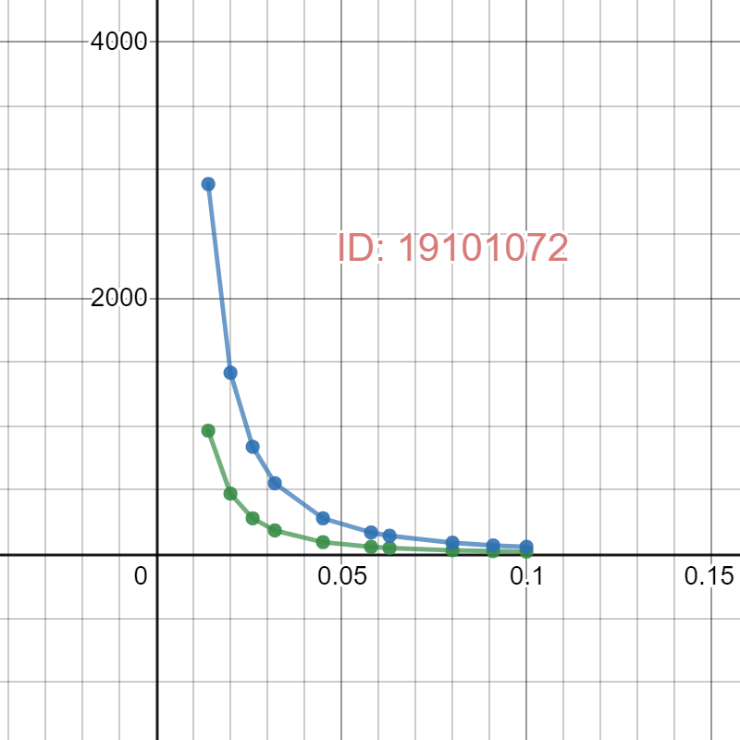

1. Draw https://www.google.com/chart?cht=tx&chf=bg,s,FFFFFF00&chco=000000&chl=log%28%7BF%7D_%7BE%7D%29 vs https://www.google.com/chart?cht=tx&chf=bg,s,FFFFFF00&chco=000000&chl=log%28r%29 graph that is you plot https://www.google.com/chart?cht=tx&chf=bg,s,FFFFFF00&chco=000000&chl=log%28r%29 along the https://www.google.com/chart?cht=tx&chf=bg,s,FFFFFF00&chco=000000&chl=x axis and  https://www.google.com/chart?cht=tx&chf=bg,s,FFFFFF00&chco=000000&chl=log%28%7BF%7D_%7BE%7D%29 along the https://www.google.com/chart?cht=tx&chf=bg,s,FFFFFF00&chco=000000&chl=y axis. For two tables you will get two lines. Find the slope from both of the straight lines you get.

Slope from line 1: -2

Slope from line 2: -2.00388

Mean slope: -2.00194

Standard deviation: 0.0019

Insert the **graph-2**here:

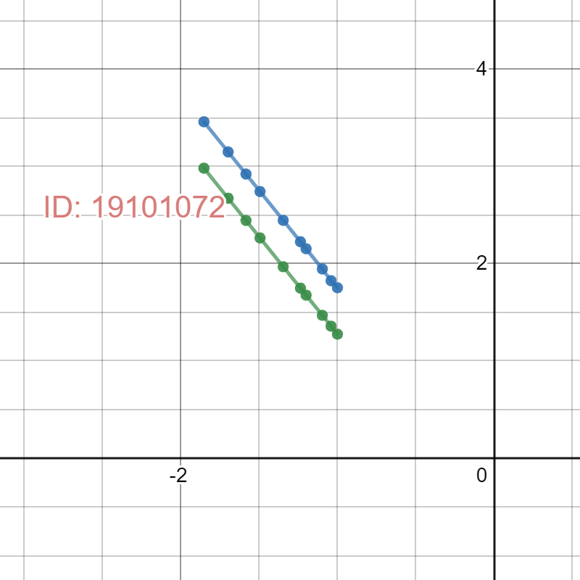

1. Draw the Electrostatic Force, https://www.google.com/chart?cht=tx&chf=bg,s,FFFFFF00&chco=000000&chl=%7BF%7D_%7BE%7D vs inverse square distance, https://www.google.com/chart?cht=tx&chf=bg,s,FFFFFF00&chco=000000&chl=1%2F%7Br%7D%5E%7B2%5C+%7D curve. You plot https://www.google.com/chart?cht=tx&chf=bg,s,FFFFFF00&chco=000000&chl=1%2F%7Br%7D%5E%7B2%5C+%7D along the https://www.google.com/chart?cht=tx&chf=bg,s,FFFFFF00&chco=000000&chl=x axis and  https://www.google.com/chart?cht=tx&chf=bg,s,FFFFFF00&chco=000000&chl=%7BF%7D_%7BE%7D along the https://www.google.com/chart?cht=tx&chf=bg,s,FFFFFF00&chco=000000&chl=y axis. You will get two straight lines for each table. Find the slope of each line.

Slope from line 1: 0.566283

Slope from line 2: 0.188739

For each table you have different https://www.google.com/chart?cht=tx&chf=bg,s,FFFFFF00&chco=000000&chl=%7BQ%7D_%7B1%7D and https://www.google.com/chart?cht=tx&chf=bg,s,FFFFFF00&chco=000000&chl=%7BQ%7D_%7B2%7D. Calculate https://www.google.com/chart?cht=tx&chf=bg,s,FFFFFF00&chco=000000&chl=k for each table:

https://www.google.com/chart?cht=tx&chf=bg,s,FFFFFF00&chco=000000&chl=%7Bk%7D_%7B%5C+%7D%5C+%3D%5C+slope%5C+%2F%5C+%28%7BQ%7D_%7B1%7D%7BQ%7D_%7B2%7D%29

https://www.google.com/chart?cht=tx&chf=bg,s,FFFFFF00&chco=000000&chl=k From line 1: 0.02696585714

https://www.google.com/chart?cht=tx&chf=bg,s,FFFFFF00&chco=000000&chl=k From line 2: -0.00299585714

Mean https://www.google.com/chart?cht=tx&chf=bg,s,FFFFFF00&chco=000000&chl=k : 0.012

Standard deviation: 0.015

Insert the **graph-3** here:

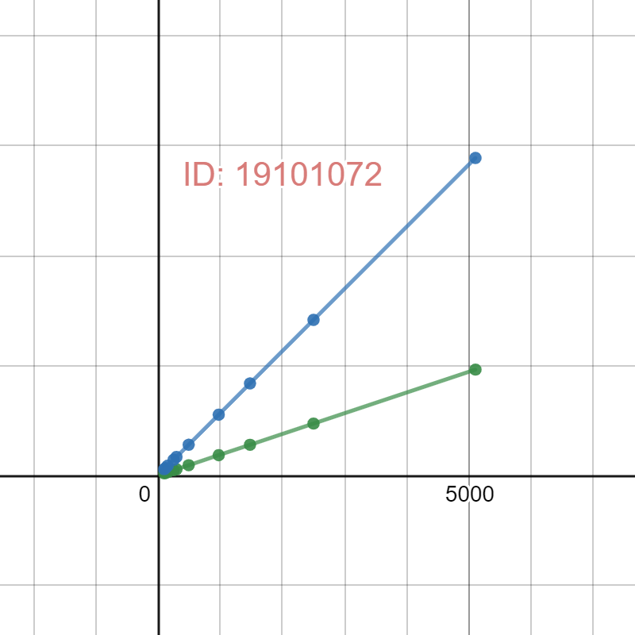

1. **Please briefly** discuss how the process of taking logs allows to find the inverse squared nature of Coulomb force and anything related to this experiment that you found interesting.  
     
   This part (step 12) is for participation grade only, so you are ***strongly*** encouraged to use your **own words**to describe your thoughts.**However, any kind of plagiarism (such as copying and pasting from other students’ lab-reports) will not be tolerated and will be subject to disciplinary action according to BracU policy.**

**Discuss here:**

What I found interesting is that the slope of log(Fe) vs log(r) graph is almost the same for both the cases. And the graph is a straight line.

Moreover, the line is in the negative x-axis and in an increasing form.

The most interesting fact which occurred to me is that the more the distance keeps increasing, the rate of decrement of force keeps decreasing.